**Notes for running iscamdelaydiff**

**Robyn Forrest, Pacific Biological Station**

**Aug 10, 2015**

**Folder structure:**

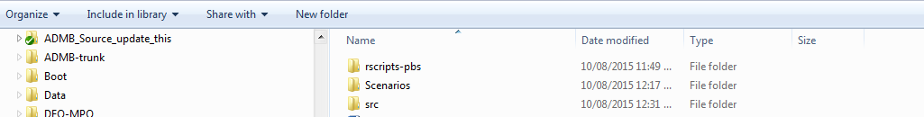

Maintain this file structure for the R tools to work.

Keep each scenario in its own folder within the Scenarios folder:

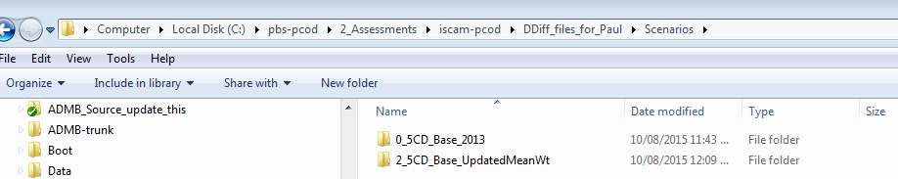

**NOTE**: Do not put any other files in the Scenarios folder. R will try to read them in as scenarios.

**Each scenario folder must contain the following files:**

baranov.cxx

iscamdelaydiff.dat (contains the names of your .dat .ctl and .pfc files)

iscamdelaydiff.exe

your.ctl (contains controls)

your.dat (contains the data)

your.pfc (contains the catch levels for the projections – MUST BE SAME UNITS AS CATCH DATA)

SensitivityGroup.txt (for grouping sensitivity cases. Can be changed on the GUI but this file needs to be there)

stats.cxx

**Optional extra files:**

clean.bat (cleans working directory of unnecessary files)

runFullMCMC.bat (runs MPD, then MCMC followed by mceval)

runMPD.bat (runs the MPD)

iscamdelaydiff.tpl (keep a copy of current tpl)

**Running in ASM or Delay Difference mode:**

**To run Age Structured Model:** This is the default, just use the command line options you would normally use

**To run Delay Difference Model:** Use –delaydiff at the command line. See the runMPD.bat file for example:

iscamdelaydiff -maxfn 2000 -crit 0.0001 **–delaydiff**

**NOTE**: in the runFullMCMC.bat file, you must use the –delaydiff command for both MCMC and mceval stages:

iscamdelaydiff -mcmc 5000000 -mcsave 5 -mcscale 5000000 -maxfn 2000 -delaydiff

iscamdelaydiff -mceval -delaydiff

**NOTE:** There is a bug in the projection year for the ASM. I found it and fixed it before in a later version but forgot how. I will track it down and let you know.

You can run the model from the GUI or in a command line window.

**To start GUI:**

Go to rscripts-pbs

Click on R data

Source pcod_iscam.r

You will see instructions:

Type pcod_iscam() to start GUI

Optional arguments: pcod_iscam(reload=T,silent=F,copyADMBExecutables=F)

Best practice is to copy and paste the second line to ensure that all scenarios are loaded:

pcod_iscam(reload=T,silent=F,copyADMBExecutables=F)

You may see error messages if you have not run MCMC and MCeval. This is not a problem but obviously the MCMC plots won’t work.

You will need to go into pcod_iscamLoadScenarios.r and change the names of your ctl and dat files:

